OOAD ASSIGNMENT

SYSTEM DOCUMENTATION

1. **Requirements elicitation**

1.1 Functional requirements

* Account opening
* Opening different account types
* Depositing funds into accounts
* Paying interest to the correct accounts
* Withdrawing funds
* Enforcing account rules
* Viewing transaction history
* Managing customer accounts

1.2 Non-functional requirements

* Maintainability
* Usability
  + - Color (intuitive design)
    - Design should be inline to modern day trends

1. **Structural UML Modelling**
   1. Use Case Diagram

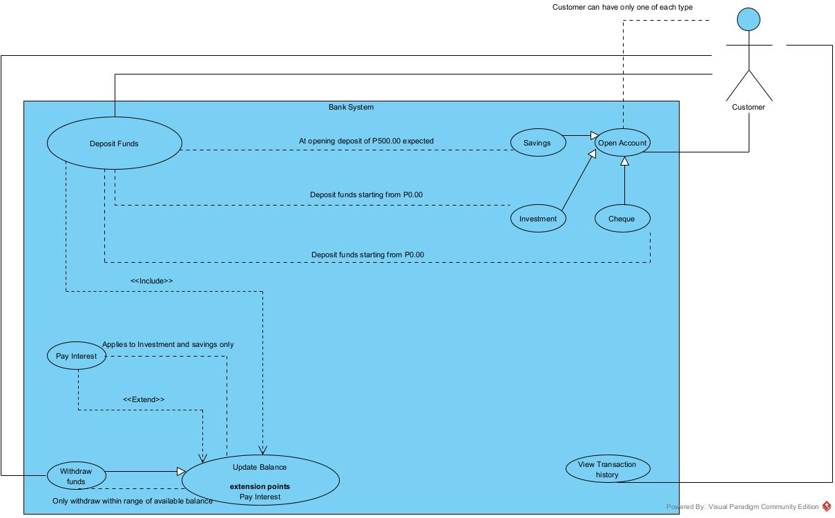

* 1. Class Diagram

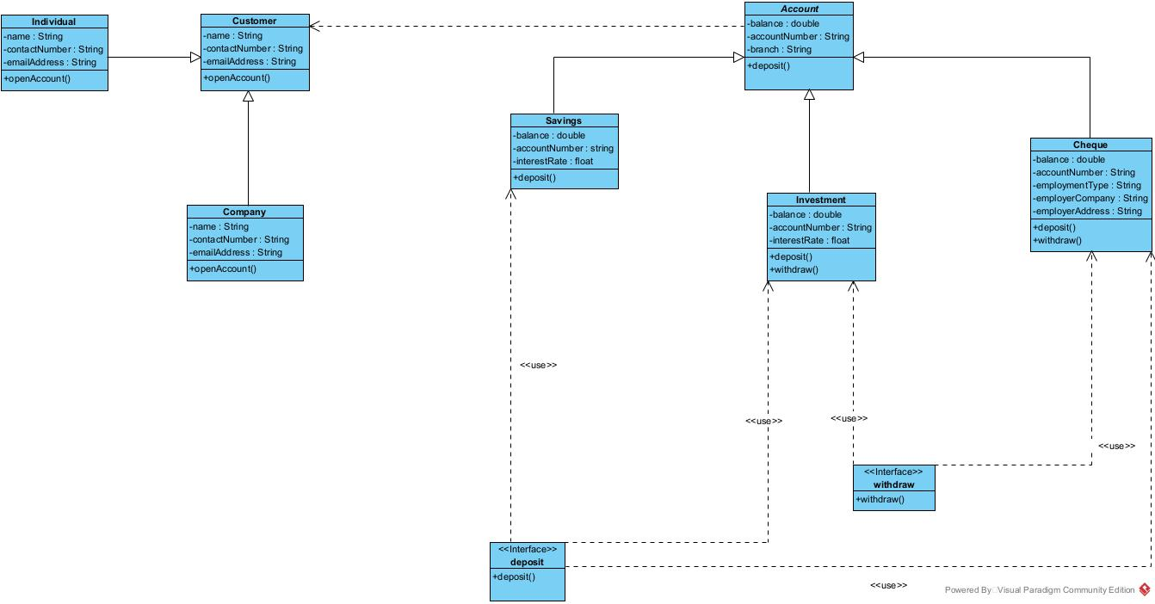

1. **Behavioral UML Modelling**

Login Sequence Diagram

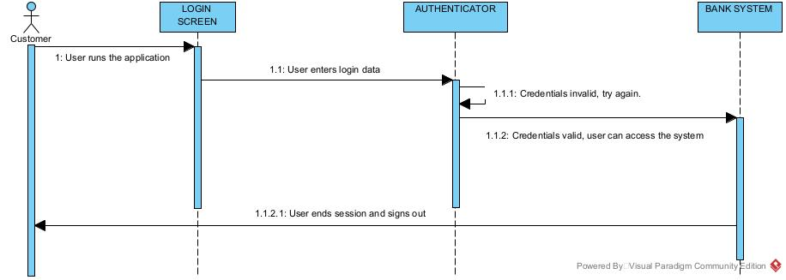

Deposit Sequence Diagram

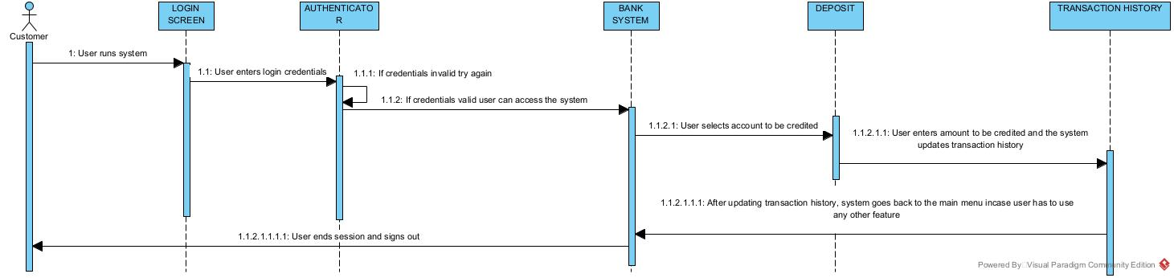

State diagram

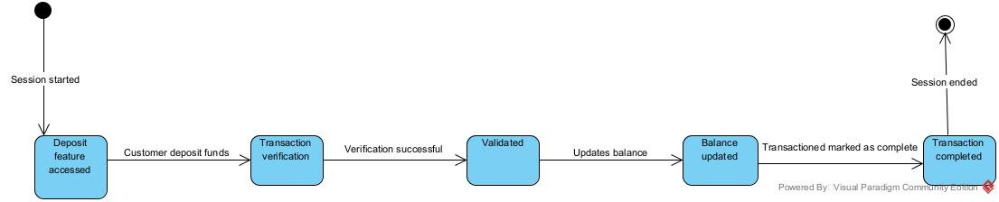

**Interview Record**

1. Time

10.35am – 12.15pm 18/09/25

1. Venue

Online via Teams

1. Interviewee

Mr. K. Baseki - Tutor

1. Interviewer

Mr. K. O Kgosimore

**Key Points**

1. Account Opening
   * + What types of accounts should the system provide?

Cheque

Savings

* + - * 0.075% company rate monthly
      * Individual 0.025% rate monthly

NB. Automated interest rate

Investment

NB. Customer must have one account of each type, accounts should not be recurring

* + - Should customers be allowed to have multiple accounts?

Yes, but one account of each type.

* + - What general details should be captured when a new account is created?

Name

Contact number

Email Address

1. Transactions
   * + What kinds of transactions should be handled by the system?

Deposit

* + - * In the investment account minimum is P500.00
      * For the other two, accounts can be opened with a minimum amount of P0.00

Withdrawal

* + - * Withdrawal within range of available balance
      * Only applies to Investment and Cheque accounts
    - What information in the transaction history should be displayed to the customer?

Date

Type of transaction

Amount (credit or debit)

Remaining balance

Credited interest rate